**Question 1.** Let , and .

(a) Find a parametric form for the line , which passes through and .

**Solution**

So is parallel to



Graph 1

Thus, a parametric form is: .

**Answer:**

(b) Find both a parametric and equational form for the line passing through and .

**Solution**

So is parallel to

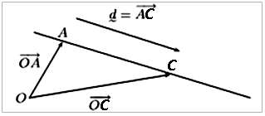

Graph 2

Thus, a parametric form is: .

If , then for some Eliminating gives:

So an equational form is:

**Answer:** , .

(c) Find the line , which passes through the origin in the direction , in equational form.

**Solution**

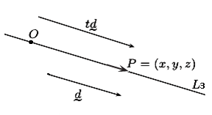

Graph 3

If is a point on the line, then

for some .

That is,

Eliminating we get two equations:

So an equational form is:

**Answer:**

(d) Does the point lie on any of the lines , or ?

**Solution**

An equational form for is:

let's substitute the point in

thus doesn’t lie on the line ;

in

thus doesn’t lie on the line ;

in

thus lies on the line .

**Answer:**  lies on the line .

(e) Does intersect with or . If so, where?

**Solution**

Suppose that and that; so,

for some

and

for some

Then we have

The first equation yields . Substituting this into the third equation gives ,

then while the second equation yields . Thus we have the contradiction. Hence no point lies on both and . i.e., and do not intersect.

If lies on both and , then we have four simultaneous equations:

From (2) and (3) we have

This gives .

From (2) and (4) we have

We get .

Thus, if lies on both and , then it is not easy to check that if , then satisfies the first equation (1):

and hence lies on both and . Hence .

**Answer:**  and do not intersect. and intersect, .

**Question 2**. Consider still the points from Question 1.

1. Using the vectors and , write the plane that contains , and in parametric form.

**Solution**

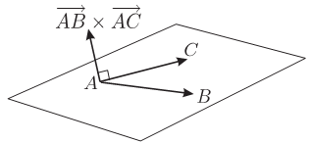

Graph 4

So that a parametric description is:

**Answer:**

1. Find the normal to , and then write in equational form.

**Solution**

A normal vector for this plane is given by:

So an equation for has the form Since lies on the plane, we have Thus an equational description is:

**Answer:**, .

1. Using the answer to (b), find another parametric form for .

**Solution**

From (b),

So that another parametric form for is

**Answer:**

1. Does the line intersect ? If so, where?

**Solution**

Suppose that and that; so,

for some

and

Substitute (1) in (2):

We get , then . Hence .

**Answer:** the line intersect , .

1. Show that the point does not lie on .

**Solution**

An equational form for is:

let's substitute the point in

thus doesn’t lie on .

**Answer:**  doesn’t lie on .

1. Referring to Section 4.4 of the notes (and the videos for week 8), find the distance of from

and from .

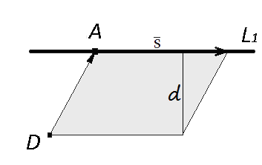

Graph 5

Consider the equational form for :

directing vector of line; coordinates of point on line.

Then ;

From properties of cross product it is known that the module of [cross product of vectors](http://onlinemschool.com/math/library/vector/multiply1/) is equal to the area of a parallelogram constructed on these vectors:

On the other hand the area of a parallelogram is equal to product of its side on height spent to this side:

Find

Then the distance of from is

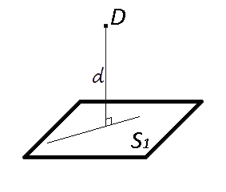

Graph 6

Consider an equational description of :

Using the formula:

find

**Answer:** the distance of from is the distance of from is

**Question 3**

(a) Write each of the following in summation notation. [Hint. Check that your general term gives

the correct starting and finishing term in the sum.]

**Solution**

For this sum ,

then

**Answer:**

**Solution**

For this sum ,

then

**Answer:**

**Solution**

For this sum ,

then

**Answer:**

(b) Use the formula for the sum of a finite geometric series to find a simple closed form for the following expression (where with ):

[**Hint**: First take out a common factor.]

**Solution**

Use the formula the sum of a geometric series for

where .

**Answer:** .

(c) Simplify the following expression. Give your answer without a summation sign.

**Solution**

then

**Answer:**3**.**

**Question 4** Write a very careful proof by mathematical induction that, for all , we have

**Solution**

**Proof**. For each , let be the sentence

**Step 1**. [We must prove .]

LHS of and

RHS of

so is true.

**Step 2**. Let and assume that is true, i.e., assume that

(

We want to prove , i.e., that

LHS of

by

=RHS of

So Thus, by the Principle of Mathematical Induction